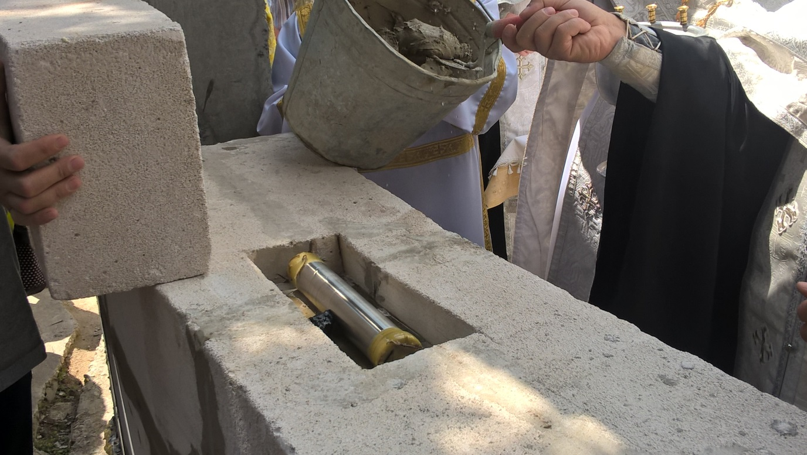

Сбербанк Sberbank
Карта Виза Visa Card: 4276 3800 4543 8756
Счет: 40820810238256500665
БИК: 044525225
КОР.СЧЁТ БАНКА: 30101810400000000225
КПП: 775003035
ИНН: 7707083893
Pay Pal Personal transfer to jar2@list.ru
Qiwi +79686618744
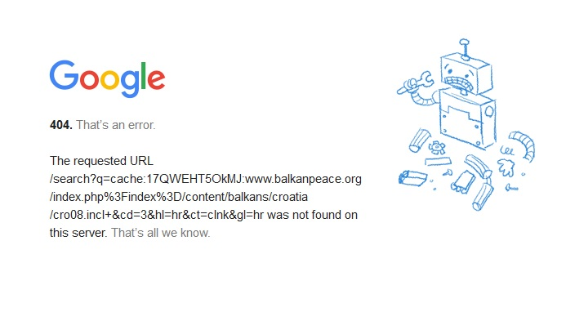
Evidence that due to Martin Brod, Tudjman wanted to go to war with NATO
Mate Granic, without Tudjman’s knowledge, ordered Ivan Penic to withdraw police forces from Martin Brod, thereby preventing a conflict with NATO. As a result, Tudjman wanted to replace both Granic and Penic
Thanks to then Foreign Affairs Minister Mate Granic, Croatia avoided going to war with NATO and SFOR on December 23, 1998 . Granic convinced the Defense and Internal Affairs Minister, Pavao Miljavac and Ivan Penic, to withdraw all military and special police forces, except for four lightly armed men, from the area of Martin Brod, a hamlet of the Croatian-Bosnian border which Tudjman claimed belonged to Croatia . He also negotiated with Robert Gelbard, then President Clinton’s special representative for the former Yugoslavia ; William Montgomery, American ambassador and Carlos Westendorp, representative of the international community in BiH; and managed to convince the Americans, NATO and SFOR troops to be patient. When Franjo Tudjman learned that his Foreign Affairs Minister had ordered the troops to be withdrawn, he became enraged and almost had Granic and Internal Affairs Minister Penic fired and replaced immediately. In recent days, a transcript has been found of a conversation between Franjo Tudjman and Ivic Pasalic held on December 24, 1998 , the day after the meeting of VONS when their proposal to go to war against the Americans and NATO was rejected. From this transcript, it is evident that Pasalic attempted to use Tudjman’s anger to definitively get even with Granic, by accusing Granic of being an American spy. He also played on Tudjman’s paranoia of conspiracies and wiretapping, frightening him with the idea that the Americans might be recording the conversations held in the Presidential Court. The entire drama, which practically pushed Croatia into an absurd war against the entire world, began on December 23, 1998 , when Canadian armed vehicles penetrated into Martin Brod. At four a.m. they there captured and disarmed four half-awake and frightened Croatian police officers and forced them back across the border into Croatia . Prior to this they had surrounded the entire village with a wire fence, removed the Croatian flags from the railway station, moved the border three kilometers further than the Croatian police officers had, buried themselves in their armored vehicles and waited for possible Croatian military action. This lightning fast military action was SFOR’s response to Tudjman’s speech at the opening of the ‘Ban Josip Jelacic’ Military School, where he praised that the international community had given up on the armed entry into Martin Brod after he personally had ordered the Croatian military and police to oppose SFOR with weapons. The United Stated and EU formed the opinion that such insolence on the part of Tudjman should receive the harshest of responses, and that it was necessary to penalize and humiliate him. In Washington and Brussels , they concluded that no one could threaten SFOR and NATO and not be penalized.

Tudjman’s Anger
As soon as Tudjman learned of the SFOR military intervention, he called an emergency meeting of the Council for Defense and National Security (VONS). He was very offended and embarrassed. He burst into the Presidential Court with a fury and immediately launched a harsh verbal attack on Internal Affairs Minister Ivan Penic. According to the testimony of those present, the atmosphere at that VONS meeting was more tense than ever. On March 10, 1999 , Nacional published a very detailed account of the events of that dramatic meeting: "All those present were astonished listening to the fury pouring out of President Tudjman, who did not carefully select his words in offending and humiliating Minister Penic. Only after a few minutes after the President’s rage, did the dumbfounded and terrified Penic manage to let out a few words and ask what the matter was. This only further enraged the President who then asked irritatedly: ‘How did your boys give in without a fight? How could they let them disarm them, why didn’t they shoot? Defend themselves?’

Pasalic’s Idea
Minister Penic answered that there were only four police officers in Martin Brod, and that they were armed only with light personal weapons and were unable to oppose the Canadian commandos who had entered the village with eight armored transporters. ‘Had they have fired, someone certainly would have been killed’, was the conclusion by the jaded Penic. ‘So what then? They should have fired, at least there would have been casualties on both sides. This would have only acted to further mobilize and homogenize the Croats, and would have let SFOR know that they cannot do whatever they want. Regardless of the possible casualties, they were obligated to resist the Canadians’, were Tudjman’s words." At that point, as Nacional’s source claims, Mate Granic spoke up and admitted that it had been he who had suggested to Minister Penic that the troops should be withdrawn from Martin Brod, but only following an agreement with President Tudjman whom he informed of his conversations with the international community. At Granic’s comments, the President exploded: "I knew you had to have your hands involved in this". Then he glared furiously at Penic and Miljavac and demanded in a heightened tone: "Who here is the Supreme Commander, whose orders do you obey, mine or Granic’s?" This article by Nacional aroused general astonishment in the public, as this was the first public indication that President Tudjman, fighting against a serious illness, was prepared to do something crazy. However, considering that he was beside himself over the scandal, he did not dare to public comment on the events from the VONS meeting. At that meeting, all of the members of VONS, with the exception of Ivic Pasalic, opposed entering an armed conflict with SFOR and NATO, for they were aware that this would have only lead Croatia to complete catastrophe. After Tudjman scornfully rejected the warning that NATO and the Americans could potentially become involved in the conflict, Pasalic spoke up. "If it is no longer possible to get back Martin Brod, then why wouldn’t our military and police forces return the blow and take Kostajnica and Zeljava", was Pasalic’s question to the dumbfounded remaining members of VONS who were against any kind of conflict with the international community. This idea, however, delighted President Tudjman. He was prepared to give orders and to get into action, but he gave in upon the urgings of all of the remaining members of VONS.

Ivan Simonovic
At that time, Nacional did not publish that the Croatian ambassador to the UN, Ivan Simonovic, who was also present at the meeting, warned President Tudjman and the remaining members of VONS that he possessed reliable information that the Americans were willing to send F-16s in the attack if Croatia were to oppose the SFOR forces. Witnesses claim that Granic was only one step away from being fired. Tudjman was so infuriated that his minister had taken matters into his own hands and given orders to other ministers, that it seemed certain to everyone present that Granic’s career was doomed. The new documents found in the presidential archives show that Ivic Pasalic attempted to take advantage of Tudjman’s rage in order to free himself forever of his greatest political opponent. The day after the VONS meeting, on December 24, 1998 , Pasalic came to Tudjman to warn him of a detail within the notes of Miomir Zuzul, Croatian ambassador to the US , concerning a conversation with Robert Gelbard. Pasalic told Tudjman that Gelbard had Zuzul had met with Gelbard only hours after the VONS meeting, and that Clinton’s advisor already knew of the discussion held on Pantovcak. As a result, Pasalic suggests to Tudjman: "Gelbard emphasized that he was shocked by the radical options proposed to President Tudjman at the emergency meeting of VONS which he very wisely rejected. Concretely, he said that Zlatko Matesa and Ivic Pasalic had suggested that SFOR be attacked, showing with this just how well he personally, and the American side, were well acquainted with the details of the VONS meeting. This is a catastrophe. This is the answer to your question of yesterday at lunch as to why Solana and Clark called. This means, either they are listening to us, or they have an agent within our ranks, there is no third option. I don’t see a third option. President: There is no third option. Ivic Pasalic: This morning I called SZUP and HIS, the experts who deal with this - exclude, the possibility of wiretapping from outside is theoretical. Thus, there is no way to listen to this space from outside. Following this, Tudjman asked Pasalic to repeated what exactly Gelbard had said. After repeating that Gelbard had known exactly that Matesa and Pasalic had convinced Tudjman to attack SFOR, he concluded: "I called the people from HIS and SZUP and they told me it is theoretically possible to listen from outside, but there is the possibility of listening from within. I would propose the following: that we have them look over the place to exclude that theoretical possibility that there is some bug inside, and if we can exclude that then this means, Mr. President, that one of the ten people who were sitting there, among them is either an agent or a lunatic." Then Tudjman recalled that Vesna Skare-Ozbolt was also at the meeting, and Pasalic mentioned Ivan Simonovic. Then Pasalic again, for the third time, repeats that Gelbard knew of the contents of the meeting stating that this was all "dreadful, Mr. President. Just dreadful". Then Pasalic describes for Tudjman his conversation with ambassador Montgomery. "I’m playing a game here, because it’s in our interest that we have a channel with him, but his position is more or less that he is very sorry it has come to this, that he is trying very hard to shift those relations and that he blames Westendorp for this-"

Anti-intelligence Examination
Pasalic asked Tudjman if he could discuss with General Kaspar that an anti-intelligence examination of the Presidential Court be made that same day, and not waiting for an answer he continued: "I’ll tell you honestly - my first two doubts, one is Mate Granic, the other is Simonovic. In his notes, I don’t know whether you’ve read them, the conversation between Klein and Harcenk, he talks about how Westendorp sent three letters to the Croatian officials in which he requested the withdrawal of Croatian police from Martin Brod, which the Foreign Affairs Minister for Croatia promised the commission after the meeting. Considering that this promise was not kept, the international community was forced to take further actions-
President: I gave Penic a specific order-
Ivic Pasalic: I asked Penic later - Ivan, how sloppy was that. He said - I didn’t want to say in there, but Granic told me before Madrid that everything was agreed and to withdraw the police, to withdraw the forces. This is not a game, Mr. President.
President: I said, if necessary, not only the police, we’ll bring in the army. Moric had some 40-50 special troops there and what Penic is saying-
Ivic Pasalic: Yes, and then he told them to withdraw, and they were all pulled out. Yesterday I was at the celebration for the special police, I talked to the commanders, I asked them - where you there, did you have knowledge and forces, could you have prevented them, without any problems.
President: It’s not a matter of whether they could have held them off, they should have offered resistance, they should have fired-
Ivic Pasalic: I agree, Mr. President, but had there been enabled troops there, but there were only four police officers with pistols, they, forgive me, shit themselves. But this guy told me that Granic said, this is what Penic said to me yesterday after the meeting and later in the Police Academy , that Granic had told him that everything was agreed and to withdraw the forces. There were some 50 members of the special police positioned there.
President: I beg your pardon, he is not Penic’s boss-
Ivic Pasalic: That’s what I told him - did the President give you that order-
President: What did he say?
Ivic Pasalic: He said - I thought it was all agreed.
President: If I weren’t in these position, for I already replaced the Foreign Affairs Minister-
Ivic Pasalic: I gathered that yesterday from your tone at the meeting.
President: And if I weren’t facing these problems with the agencies and the government reorganization, I would replace-
Ivic Pasalic: You saw yesterday that Mate was dejected. I told Ivan - you know who your supreme commander is, and what Granic told you means, but likely Granic’s story - it’s all been agreed with the President and so on. Of course the police and defense ministers cannot accept any parallel commands, except from you, if you didn’t repeal, that is clear, that is logical.
President: At the very least, it’s worth looking into. This is dreadful, and all in one day.
After this, Pasalic returns to the conversation between Gelbard and Zuzul in order to further upset Tudjman.
Ivic Pasalic: Because, he demonstrated, he said this intentionally to show us that they know everything, he didn’t say this flippantly. He sent a message saying, you won’t play around with me, we know everything, that’s the message. That’s too great for him to say that flippantly.
President: It can be interpreted that way, but perhaps-
Ivic Pasalic: Mr. President, he mentions names, Matesa’s and mine.
President: No other names?
Ivic Pasalic: No, Matesa and me. This was a demonstration to show me that they know everything which you say at our most confidential meetings. We are a force, we have everything, we have our people, there is no other option.

Espionage Paranoia
After touching very briefly on several other themes including the statements by Consul Bernard Jurlin, Ploce, attorney Rivkin, Tuta, Stela and the pressures to extradite, the conversation which began at 11:50 a.m. concluded at exactly 12 noon. Witnesses have confirmed for Nacional that there really was an anti-intelligence search through the rooms where the meeting was held, but, indeed, no listening devices were found. In this way Pasalic could warm up Tudjman’s espionage paranoia and present him with another piece of evidence that an American spy was residing among the members of VONS. However, considering that he had no concrete proof against Granic, there was no reason for his replacement. However, Granic carried the label of American spy, which Pasalic plastered on him, until the very end of his mandate. The only thing left unclear is how former premier Zlatko Matesa was falsely accused of supporting the attack on SFOR, when he in truth did not support this. That is, only Pasalic was in support of Tudjman on this theme.

Indisputable Arguments
The discovered transcripts confirm that the former Foreign Affairs Minister Mate Granic, like many times before, played an immeasurably important and positive role in the case of Martin Brod. Thanks only to his efforts, and courage in manipulating Minister Penic, a war catastrophe and conflict with the international community was prevented. Granic found himself in a similar situation in the spring of 1999 when he single-handedly, without consulting Tudjman, made an agreement with NATO and Washington concerning the use of Croatian air space in the attacks on Yugoslavia . Similar to the event at Martin Brod, Tudjman furiously approached Granic after the first attacks on Belgrade and asked him who had given him the right to decide on such important matters with consulting the president. Granic then responded before all of the VONS members: "I decided for NATO and for democracy, and against Milosevic". Not even Tudjman could react to that argument, although many expected that he would replace Granic for his insolence.

